

THE LIFT PROJECT IS A LIFESTYLE-BASED WELLBEING PROGRAM
DESIGNED TO LIFT YOUR MOOD AND YOUR LIFE!

DEVELOPED AND PRESENTED BY DR DARREN MORTON
INTERNATIONALLY RECOGNISED LIFESTYLE MEDICINE EXPERT

10 FASCINATING LESSONS.
CHOOSE YOUR OWN ADVENTURE!



It’s fun and simple,
and it combines
evidence-based strategies
from the exciting fields of
neuroscience, positive psychology
and lifestyle medicine.

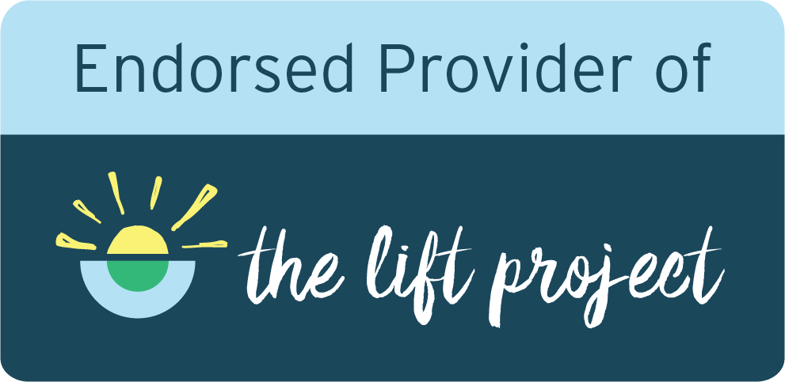

The Lift Project is certified by the American College of Lifestyle Medicine,
and endorsed by the Australasian Society of Lifestyle Medicine.

www.theliftproject.global | contact@theliftproject.global

