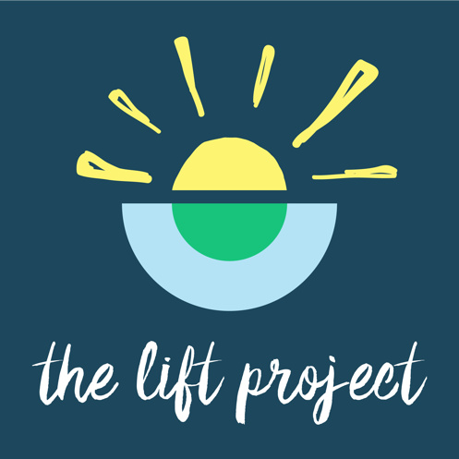

The Lift Project is a lifestyle-based wellbeing program that uniquely brings together science-based strategies from research in the fields of Neuroscience, Lifestyle Medicine, and Positive Psychology.

The Lift Project is lifting lives around the globe by equipping individuals to take charge of their own wellbeing, build resilience, and live a happier life.

Developed and presented by internationally recognised wellbeing expert, Dr Darren Morton, The Lift Project explores 10 wellbeing-enhancing topics over 10 weeks (with an emphasis on mental wellbeing) that are designed to lift individuals, groups, organisations, and entire communities!

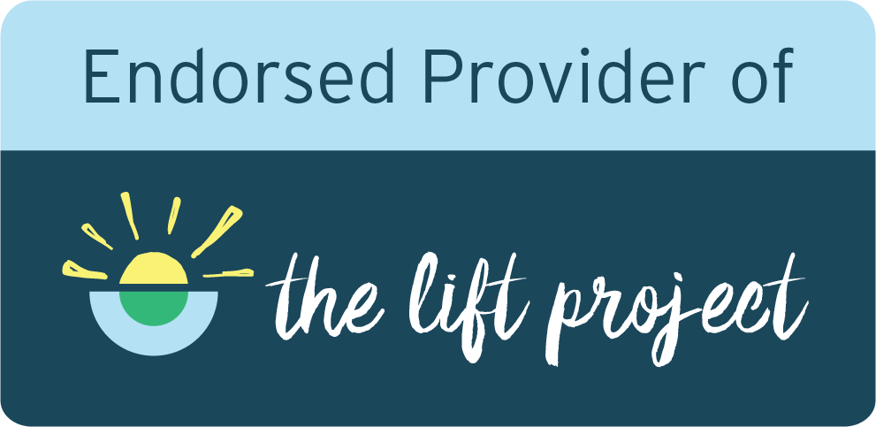

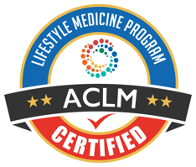

The Lift Project is certified by the American College of Lifestyle Medicine,
and endorsed by the Australasian Society of Lifestyle Medicine.

www.theliftproject.global | contact@theliftproject.global

